|  |
| --- |
|  |
| Solution Architecture Document |
|  |
| Compass Surveys |
| **Author**  **Tayyab Shahid**  **30/01/2021** |

Document Control

**Version History**

|  |  |  |  |
| --- | --- | --- | --- |
| **Version** | **Date** | **Author** | **Key changes** |
|  |  |  |  |
|  |  |  |  |
|  |  |  |  |
|  |  |  |  |
|  |  |  |  |

**Distribution**

|  |  |  |
| --- | --- | --- |
| **Name** | **Position title** | **Date** |
|  |  |  |
|  |  |  |
|  |  |  |
|  |  |  |
|  |  |  |

**Document References**

|  |  |  |
| --- | --- | --- |
| **#** | **Title** | **Link** |
|  |  |  |
|  |  |  |
|  |  |  |
|  |  |  |
|  |  |  |

Contents

1. Introduction 4

1.1 Document Purpose 4

1.2 Document Scope 4

1.3 Document Audience 4

1.4 Definitions 4

2. Solution Overview 5

2.1 Solution Objectives 5

2.2 Solution Scope 5

2.2.1 In Scope 5

2.2.2 Out of Scope 5

2.3 Assumptions 5

2.4 Constraints 5

2.5 Dependencies 5

3. Technologies to Use. 6

3.1 .Net Core Web API 6

3.2 SQL Server to persist data 6

3.3 Source Control 6

4. Database Entities 7

5. Folder Structure 8

6. End Points 9

6.1 Get All Surveys - /api/surveys 9

6.2 Get Survey - /api/survey/{id} 9

6.3 Add Survey 9

6.4 Submit Survey Results 9

7. Tests Design 9

# Introduction

## Document Purpose

The purpose of this document is to describe the backend solution design for the Compass Survey Application.

## Document Scope

The scope of this document is limited backed API only.

## Document Audience

The audience for this document includes:

* **Project Leadership Team:**
* **Development Team:**

## Definitions

The following acronyms and definitions will be used in the Compass Surveys and within this document.

| **Term/Acronym** | **Definition** |
| --- | --- |
|  |  |
|  |  |
|  |  |
|  |  |

# Solution Overview

The backend API solution will be responsible to handle all HTTP requests from the client app for Compass Surveys.

## Solution Objectives

The solution will provide list of surveys, individual survey details and will also be handling Post requests to persist the data into the database.

## Solution Scope

### In Scope

The functional scope for the project includes:

*Backend API*

*Tests*

### Out of Scope

The following are deemed out of scope:

Frontend Application

## Assumptions

The following assumptions will be validated as part of solution design and implementation:

## Constraints

The following constraints apply to the Compass Survey:

## Dependencies

The solution is dependent on the following items:

# Technologies to Use.

## .Net Core Web API

[*details*]

## SQL Server to persist data

[*details*]

## Source Control

[*details*]

# Database Entities

# Folder Structure

The following folder structure to be followed for the API.

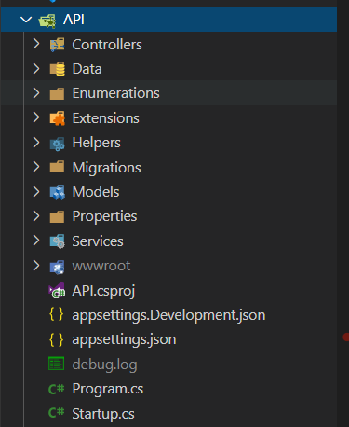

# End Points

The API should provide the following endpoints.

## Get All Surveys - /api/surveys

Details

## Get Survey - /api/survey/{id}

Details

## Add Survey

Details

## Submit Survey Results

Details

# Tests Design

Following tests to be implemented using xUnit framework.

Details